

Example ICT Accessibility Risk Scoring System
This guide helps procurement and accessibility teams create a system to assess the risk level of IT software acquisitions using a standardized scoring system. The score informs the level of accessibility review and mitigation required before procurement. The principles in this document can be applied as is or adapted to your campus; the result should be a consistent method to determine the level of accessibility review required for IT Acquisitions. Determining risk is an essential component of the CSU ATI Accessible Procurement Framework and helps campuses maximize their capacity, reduce risk, and document their process.

Overview of a Scoring System
The system is built around two key scores:
- IS (Impact Score): Measures the likelihood and severity of accessibility barriers in the product or system.
- US (Use Score): Measures the extent and criticality of the product’s use within the organization.

These two scores are combined to produce the Total Risk Score (TRS), which determines the accessibility risk level and appropriate procurement decision path.

Scoring Each Dimension

Impact Score (IS)

Score the product on a scale from 1 to 5:
- 1 = Minimal barriers: Highly accessible product, e.g., Section 508-conformant with third-party validation.
- 5 = High likelihood of barriers: Poor or no accessibility documentation, known issues, non-compliance with WCAG/508, or high-severity barriers.

Consider:
- Vendor’s accessibility documentation (VPAT, HECVAT).
- Past accessibility findings or audits (known issues)
- Product type (e.g., visual dashboards).
- Compatibility with assistive technologies.

Use Score (US)

Score the product on a scale from 1 to 5:
- 1 = Minimal use: Used by a few users with little functional impact.
- 5 = Critical use: Required by all users, including employees, or essential for business functions.

Consider:
- Number and diversity of users (e.g., employees, students, the public).
- Whether use is mandatory or optional.
- Business function supported (e.g., payroll, learning systems).
- Alternatives are available.

Calculating the Total Risk Score (TRS)
The TRS provides a quantifiable, repeatable, consistent method to proceed with your conformance review.

Total Risk Score (TRS) = IS + US

TRS will fall between 2 (lowest risk) and 10 (highest risk).

Determining the Risk Level and Procurement Action
TRS | Risk Level | Procurement Decision
9 – 10 | Critical Risk | Must reject unless vendor remediates serious accessibility barriers. Strongly re-consider business case. Administrative sign-of at highest level required to accept risk.
7 – 8 | High Risk | ACR review, Require an TAAP (Temporary Alternate Access Plan, formerly EEAAP) if barriers exist that impede core functions. Request vendor accessibility roadmap. Consider a vendor demo to validate vendor statements if confidence is low or documentation is poor. Include procurement language in contract with timelines for vendor to produce updated documentation, remediate, etc.
5 – 6 | Moderate Risk | Acceptable only with Accessibility Conformance. Report (ACR; VPAT, HECVAT) review
3 – 4 | Low Risk | Proceed; minor accessibility concerns, watch for use creep/adoption at renewal or with subsequent independent acquisitions.
2 | Minimal Risk | Approved for procurement without additional accessibility work.

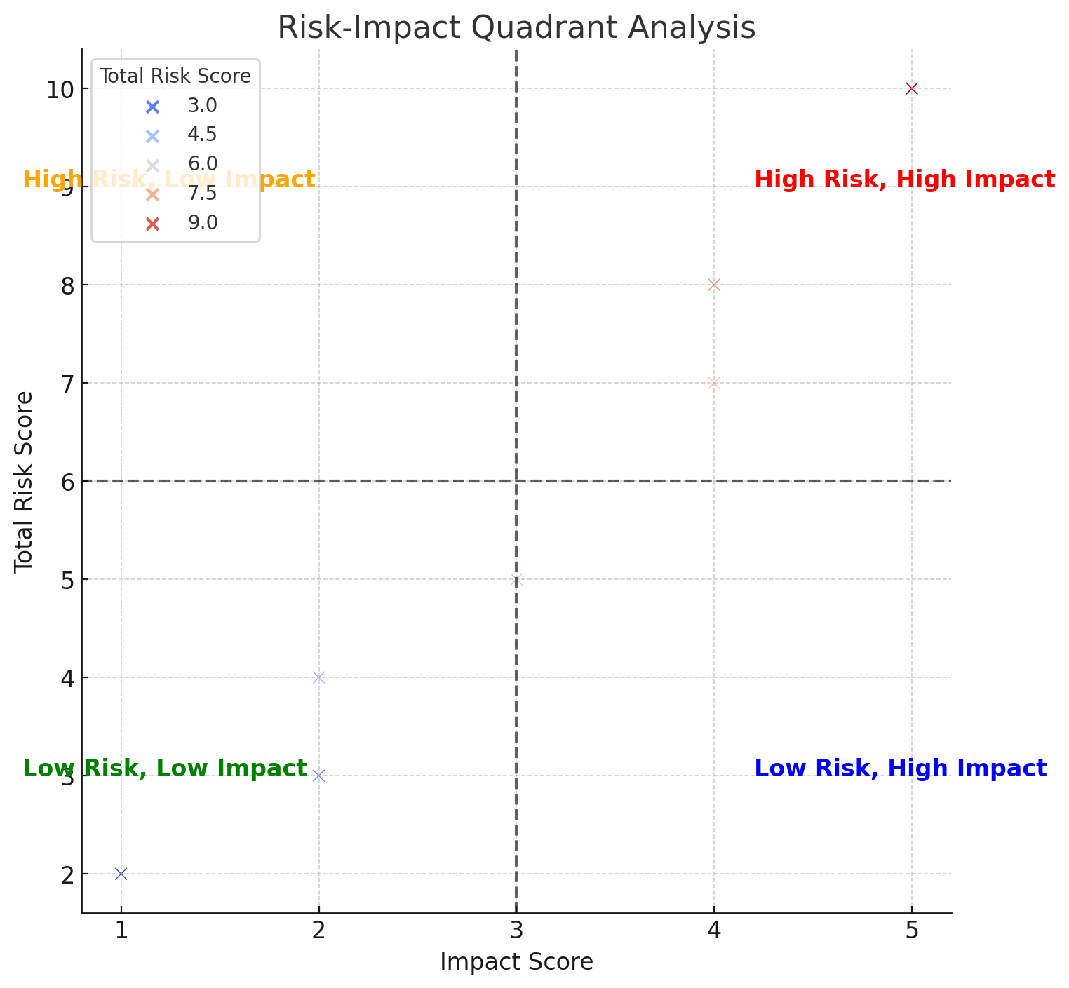

Practical Steps for Use
- Gather information:
- Review VPAT/HECVAT/accessibility statements
- Ask the vendor for accessibility contact and end-user support for accessibility barriers
- Conduct vendor accessibility demo if documentation is of poor quality
- Score IS and US:
- Collaborate with both technical and functional stakeholders.
- Calculate TRS:
- Sum the IS and US.
- Make a decision:
- Refer to the risk level table to determine next steps.
- Document
- If high impact with barriers to core functionality, create a TAAP (formerly EEAAP)
- Track and follow up:
- Ensure any required plans or vendor commitments are implemented.
- Ask for a vendor accessibility roadmap; their timeline for remediating barriers.
- Plan for re-evaluation at acquisition/renewal.

Associated Accessible Procurement Documents/Processes

- Overview of CSU ATI Accessible Procurement Framework
- Vendor Accessibility Roadmap
- Temporary Alternate Access Plan (TPAA, formerly EEAAP)
- Vendor Demo instructions
- Example scoring spreadsheet
- Accessibility Statement Recommendations

